William Mackay
MTH 337, Professor Adam Cunningham

Weekly Report 07
Introduction
Newton's method is a root finding method for nonlinear equations that iterates the equation x_{i+1}=x_{i}-(f(x)/f'(x)) in order to find the x value that satisfies the function f(x). This method is a very important tool for solving nonlinear equations and systems of equations, and is often favored because of its relatively quick rate of convergence. While other methods, such as bisection, converge linearly, Newton's method converges quadratically. Newton's method, however, works poorly with some functions where the derivative approaches 0 at points. For functions such as these, the initial value that is chosen can determine whether or not Newton's method converges at all. In this assignment, Newton's method was tested on the function f(z)=z³-1 for z values in the imaginary plane. A Python script was written to test many points on the imaginary plane to see whether or not these points converged to one of three roots over 20 iterations of Newton's method. The script then generated an image that showed to which root each value converged, if it converged, by coloring each point either red, blue, or green. Another image was generated in which the rate of convergence was encoded into the brightness of each color.
Approach
The sample of complex points was generated using the numpy functions linspace and meshgrid. The result was a 2-dimensional array of complex points whose real components ranged from -1 to 1 and whose imaginary components ranged from -1j to 1j. For the first image, the array of z values was 1000 by 1000. Once the array of z values to be tested had been generated, Newton's method was performed on each element. The derivative function f(z)=z³-1 was f'(z)=3z², so in each iteration, f(z)/f'(z) was subtracted from the previous value of z. This was done 20 times so that the vast majority of the points would converge. Once this was done, the resulting z array was checked to see which initial values had converged to which roots. Three Boolean arrays were generated, red, green, and blue, which contained True and False elements. For the red array, the True elements were those from the z array that converged to the root. For the green array, the True elements were those that converged to the root. For the blue array, the True elements were those that converged to the root. These arrays were then applied to img, a three dimensional array. The red, green, and blue arrays were used to slice the 0th, 1st, and 2nd elements of the array's third dimension, respectively, which determined the color of each pixel when imshow was used with img. To generate an image in which the number of iterations required to converge to a root was encoded into the brightness of the color of each pixel, some modifications had to be made. While the code was largely the same, two nested for-loops were added to the Newton's method section which checked whether or not each element had converged to a root. For each iteration in which an element in z did not converge to a root, the same element in another array, count, was increased by 1. After the loops had finished running, the count array was normalized by dividing count by the largest element of the array. Once all of this had been done, the only thing left to do was to multiply the red, green, and blue arrays by count, which resulted in an image where the brightness of the each color increased as the number of iterations required to converge increased. This modified version of the code was run for a smaller number of points due to the inefficiency incurred by adding the for-loops.
Results
Figure 1 was obtained from the unmodified version of the code. The red regions contain points that converged to the root, the green regions contain points that converged to the root, and the blue regions contain points that converged to the root.
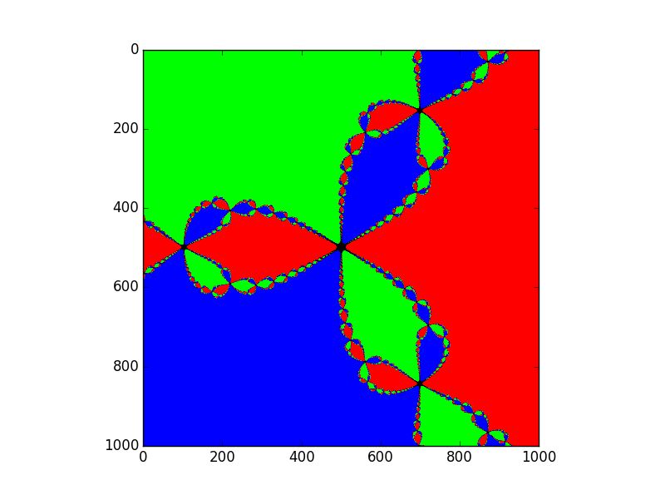Figure 1
Figure 2 shows a particularly interesting region of figure 1 in greater detail. The pixelation is a result of zooming in on figure 1.
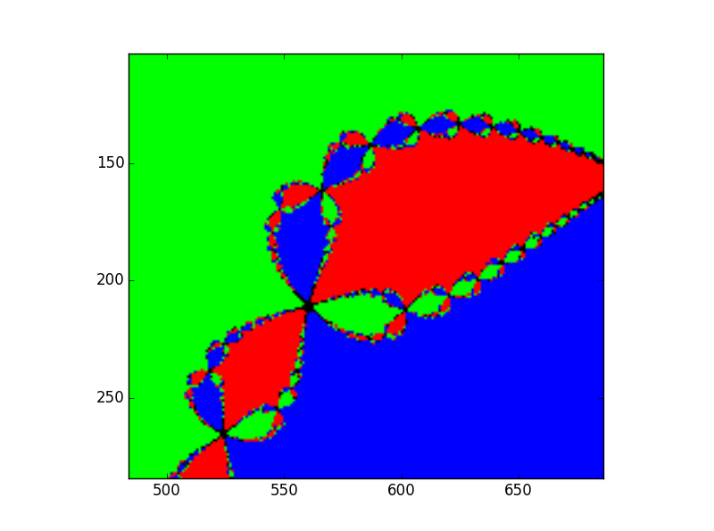Figure 2
Figure 3 shows the image that resulted from the modified version of the code. In this image, the brightness of the color is directly proportional to the number of iterations required for convergence.
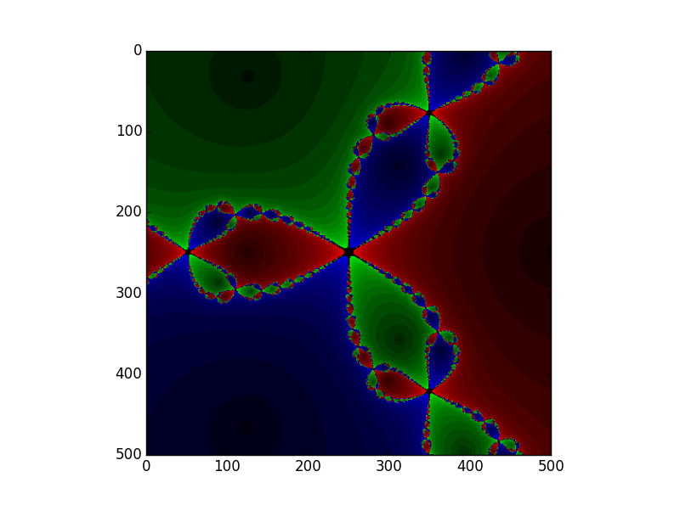
Conclusion
Interestingly, the figures generated by the code exhibit some very strange behavior. One might have expected that there would simply be three regions, each converging to a different root, but this is not the case. Instead, there are many regions of red, green, and blue in widely different areas. Not only that, but there is a distinct, repeating pattern in the figures. In figure 1, it appears that there is a repeating pattern of three 'lobes' that each converge to a different root that starts at 0 and expands outward. From figure 2, which gives a closer look at a region of figure 1, it can be seen that this pattern repeats many times, breaking into more and more smaller and smaller 'lobes'. This behavior was also seen in the mayfly model from Weekly Report 03. Like the mayfly model, this model exhibits fractal behavior, characterized by having an infinitely repeating, self similar pattern that is the same at any scale. This could be tested more thoroughly by increasing the number of points tested and increasing the number of iterations used in Newton's method, thereby increasing the resolution of the image generated by the code. Unfortunately, this would also result in a longer runtime. Also, when a larger number of points was tested with meshgrid, Python returned a memory error. Though this may have been a hardware issue, it appeared that meshgrid was not able to handle extremely large arrays, meaning another method would have been required to generate the z array.
The third figure was a modified version of the first that included variation in brightness of each color. A brighter color signified slower convergence. From this modified figure, the values at the center of each 'lobe' appear to converge the fastest and those at the edges appear to converge the slowest. The pure black regions of all three figures were areas where the z value did not converge at all. These 'holes' also appear to exhibit a pattern, existing at the center of each three 'lobe' group.
Python Code
#William Mackay
#Assignment 7- Newton's Method in the Complex Plane

from pylab import *

#Using 1000 points for increased resolution
npts = 1000
#Creating meshgrid of imaginary points
x = linspace(-1, 1, npts)
y = linspace(-1j, 1j, npts)
X, Y = meshgrid(x, y)
Z = X + Y

#Defining the three roots and the tolerance
r1 = complex(1, 0)
r2 = complex(-.5, sqrt(3)/2.)
r3 = complex(-.5, -sqrt(3)/2.)
tol = 1e-6

#Run newton's method for 10 iterations
niters = 20
for i in xrange(niters):
Z -= (Z**3 - 1)/(3*Z**2)

#Points are colored red if they converged to the first root, green for the second, and blue for the third.
reds = abs(Z - r1) < tol
greens = abs(Z - r2) < tol
blues = abs(Z - r3) < tol
#Generating an array for the image
img = zeros((npts, npts, 3))
img[:,:,0] = reds
img[:,:,1] = greens
img[:,:,2] = blues
#Shwing the first image
figure(1)
imshow(img[::-1])

#Running a modified version of the previous code which encodes the number of iterations into the coloring of the image
#Fewer points are used because this code is less efficient
npts = 500
x = linspace(-1, 1, npts)
y = linspace(-1j, 1j, npts)
X, Y = meshgrid(x, y)
Z = X + Y

r1 = complex(1, 0)
r2 = complex(-.5, sqrt(3)/2.)
r3 = complex(-.5, -sqrt(3)/2.)
tol = 1e-6

#Added nested for loop to newton's method code which increases the count for each iteration in which the value has not coveged
count=zeros((npts,npts))
niters = 20
for i in xrange(niters):
Z -= (Z**3 - 1)/(3*Z**2)
for j in xrange(npts):
for k in xrange(npts):
if abs(Z[j,k] - r1) > tol and abs(Z[j,k] - r2) > tol and abs(Z[j,k] - r3) > tol:
count[j,k]+=1
#Normalizing the count by dividing by the maximum value. Each element should be between 0 and 1 now.
count=count/amax(count)
reds = abs(Z - r1) < tol
greens = abs(Z - r2) < tol
blues = abs(Z - r3) < tol
img = zeros((npts, npts, 3))
#Multiplying color values by count so that the more iterations, the brighter the color.
img[:,:,0] = reds*(count)
img[:,:,1] = greens*(count)
img[:,:,2] = blues*(count)
figure(2)
imshow(img[::-1])

show()

